SAVE OUR BEACHES T-SHIRTS

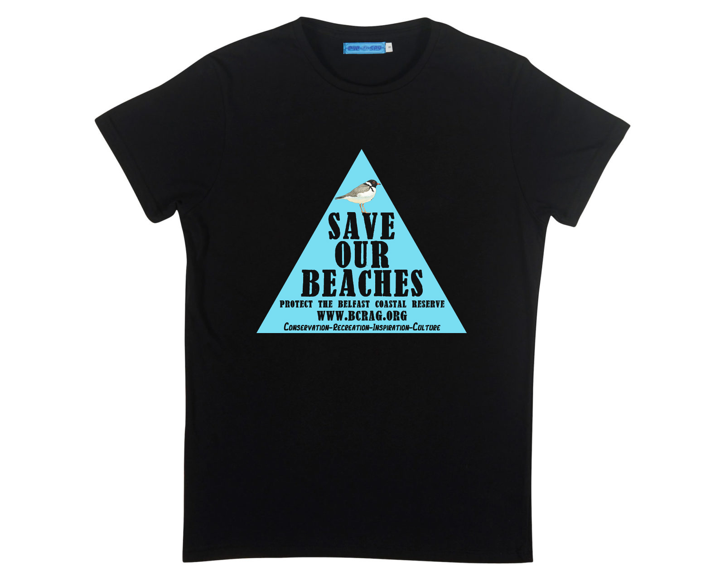

BLACK TSHIRT WITH ‘SAVE OUR BEACHES’ LOGO ON FRONT.
TSHIRT IS AUSTRALIAN MADE – (NO SWEATSHP LABOUR)
AND PRINTED IN MELBOURNE BY WHILEYOUSLEEP.COM.AU

ORDER DETAILS:

NAME:
ADDRESS:
PHONE:

TSHIRT ORDER: (MARK WITH AN ‘X’ FOR EACH TSHIRT in order)
MENS | S | M | L | XL
WOMENS | S | M | L | XL

ORDER AMOUNT:

Tshirt/s | $
Postage:  $5 per Tshirt in Australia/$10 per Tshirt Overseas. | $
TOTAL ORDER AMOUNT | $

Payments:
Please make payments to:
Account Name Goanna Arts
BSB: 013760
ACC: 520450267

**Email/post the receipt to bcrag@fastmail.com

www.bcrag.org.au

